Charotar University of Sciences and Technology

Charotar Institute of Paramedical Sciences

**Department of Operation Theater and Anesthesia Technology**

**Report on Anesthesia Technician Day Celebration 2019**

The department of **Operation theater and Anesthesia Technology**, Charotar Institute of Paramedical Sciences celebrated the **Anesthesia Technician Day 2019** on **1st April 2019** by the effective presence and participation of **Dr. Hemlata Kamat, Professor at Pramukh Swami Medical College, Karamsad.** The event was organized at **CMPICA auditorium**. All undergraduate students of CIPS participated in the event.

The event was started by a Prayer devoted to the Goddess Saraswati. Thereafter **Dr. Darshan Patel, Principal, CIPS** started the event by welcoming our chief guest Dr. Hemlata Kamat and addressing her with an enormous phrase of words. **Dr. Bala Ganpathy, Dean, Faculty of Medical Science** and **Dr. Anil Sharma, Principal of MTIN** cherished the event by their valuable presence.

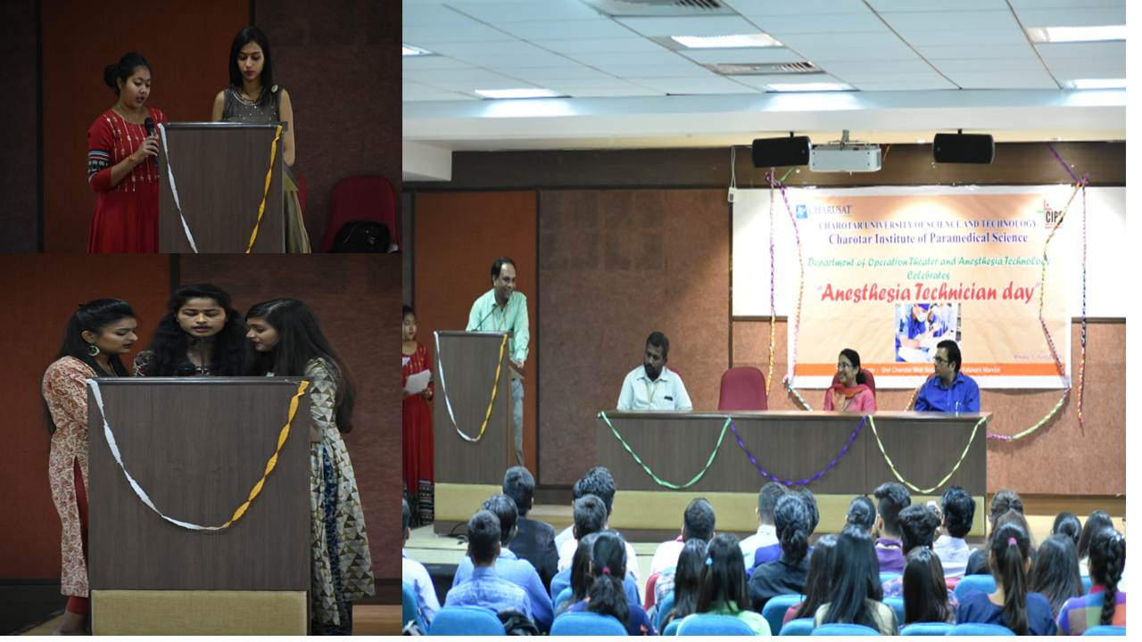

**Dr. Hemalata Kamat** gave an eminent talk on **“Recent advances in Anesthesia”**. She briefly explained the recent anesthetic drugs in use in clinical care practice.

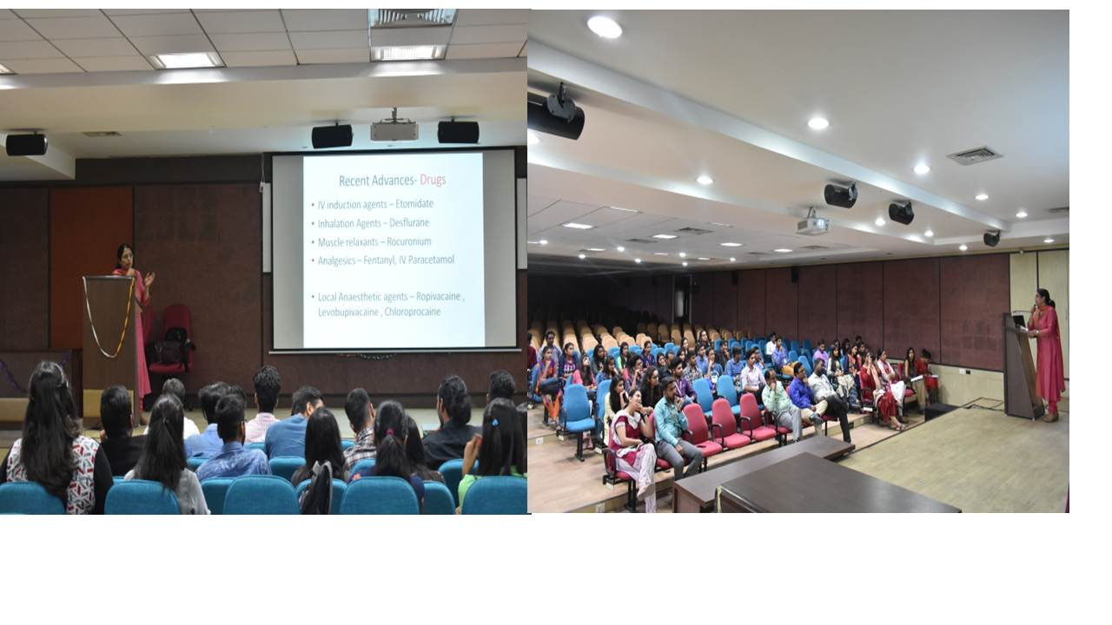

Our BOTAT students actively participated in **Poster Presentation**, **Skit** for CPR and making **Video** addressing role of healthcare personnel in emergency situation. Our chief guest showed active participation in student’s activity by guiding them the advanced leaning.

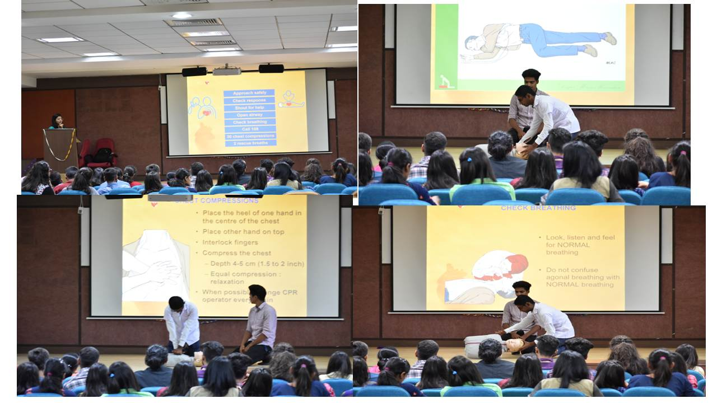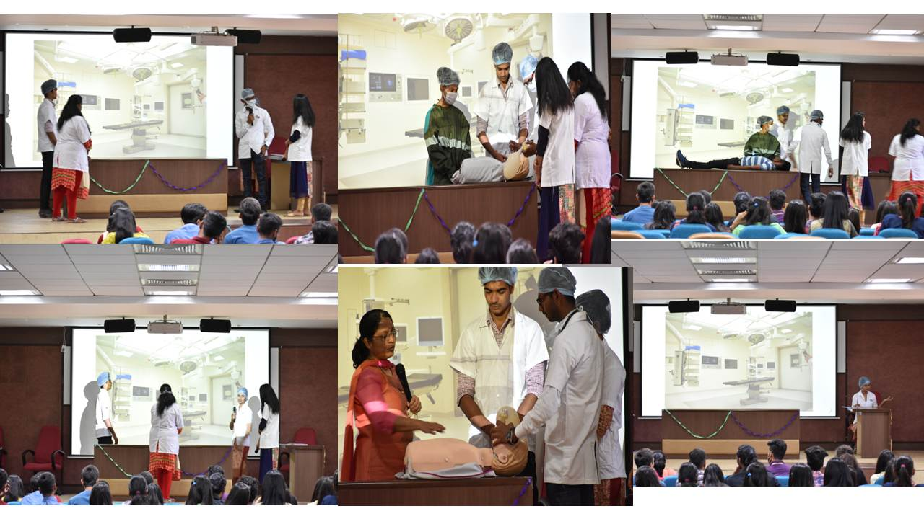

The students also participated in quiz competition. Finally, Dr. Kamat awarded the winner.

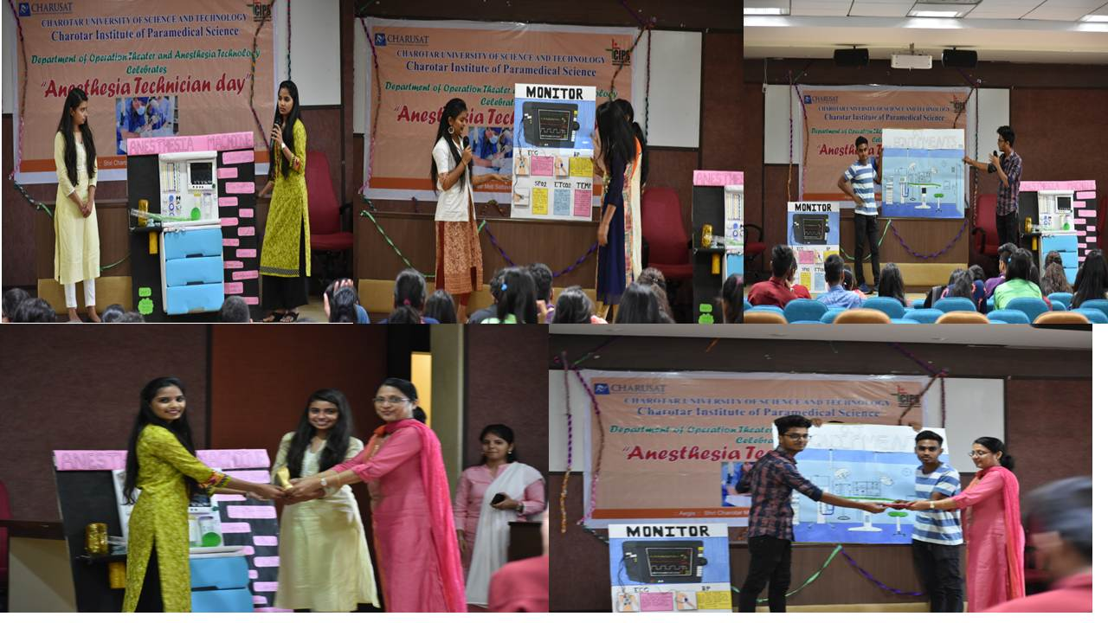

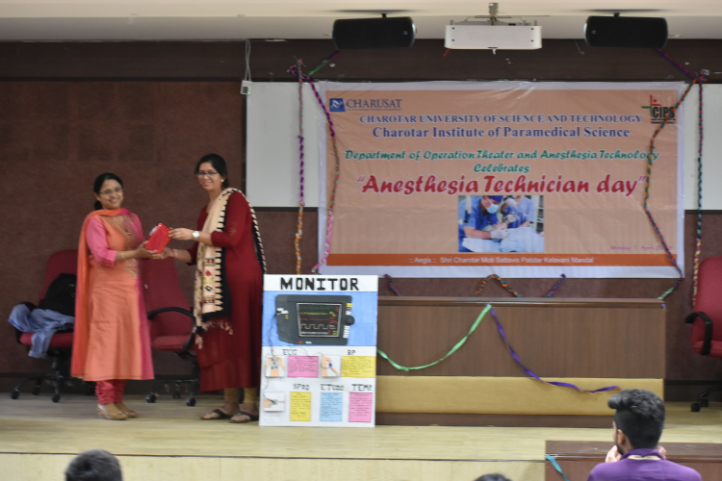

The program was concluded with gratitude by Dr. Artee Tyagi. At the end of each session, we took feedback from students which was very good, encouraged our students.

Event Coordinator,

Dr. Artee Tyagi

Incharge of OTAT Dept,

CIPS, CHARUSAT